 Series on Adversity Coping
標語Tee設計比賽
Slogan Tee Design Competition
參加表格Enrollment Form
個人參賽individual participant／小組參賽group participants*
參加者資料Participant Information
姓名Name:____________________________________________________
學生編號Student number:_________________________________________
學系Faculty: ____________________ | 年級Year: ______________________
聯絡電話Contact number: _________________________________________
電郵地址Email address: ___________________________________________
作品Design
Tee的顏色Colour of your tee*: White/ Black/ Grey/ Red/ Orange/ Yellow/ Blue/ Green
設計概念(不多於150字中文或200字英文):
Description of your design (Not more than 150 words in Chinese or 200 words in English):
_____________________________________________________________
_____________________________________________________________
_____________________________________________________________
_____________________________________________________________
_____________________________________________________________
_____________________________________________________________
_____________________________________________________________
_____________________________________________________________
* 請劃去不適用者Please delete as appropriate
查詢Enquiries: 2857 8225/ cedars-counselling@hku.hk
主辦單位：學生發展及資源中心(輔導及心理培育部)
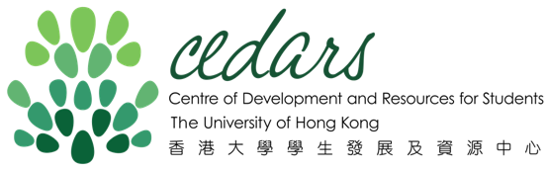
Organizer: CEDARS (Counselling and Person Enrichment)

